2025 MARRS WINTER SPORTS SCHEDULE

BOYS BASKETBALL
10/30 @ Bryan
11/5 Norris
11/6 @ Lewis & Clark
11/11 Bye (no game)
11/13 Morton
11/14 @King
11/18 Bluestem
12/2 @McMillan
12/4 Buffett
12/9 @ Beveridge
12/11 Hale
12/16 City Finals - TBD
12/17 City Finals - TBD



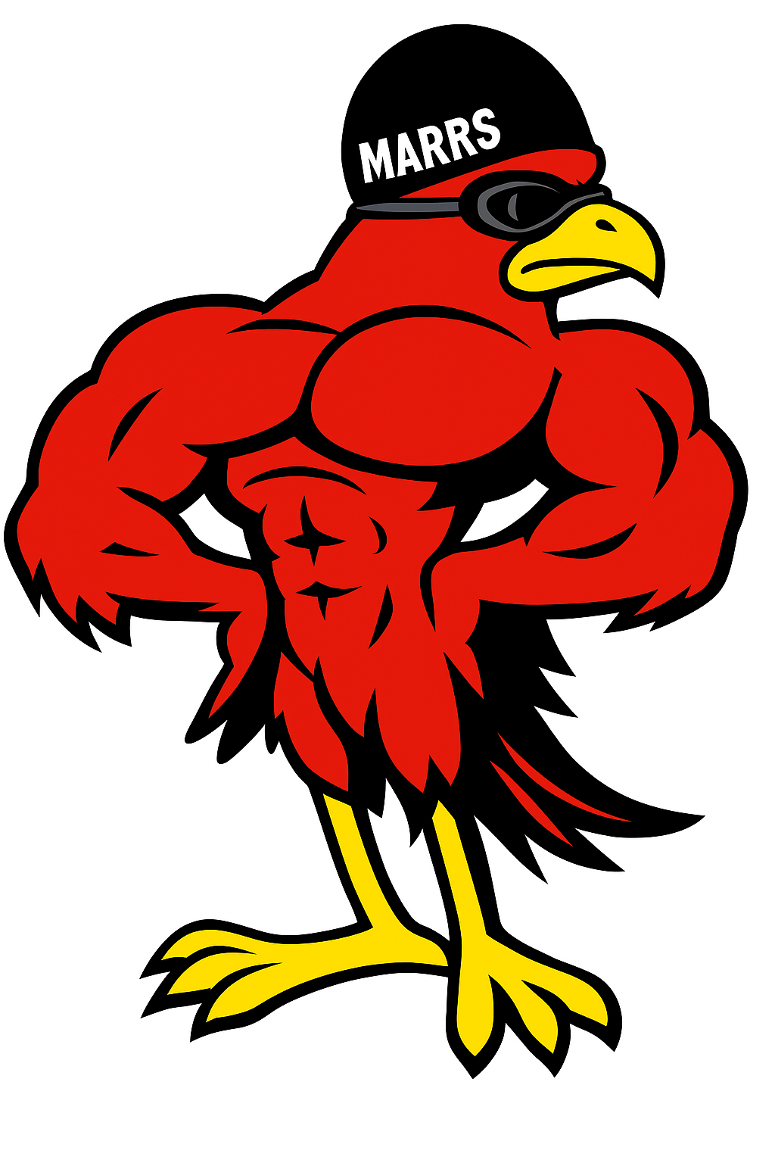
GIRLS SWIMMING
10/29 King, McMillan, Bryan @ Bryan Middle
11/5 Hale, Bluestem @ Hale
11/12 Beveridge, Davis, Morton @ Morton
11/20 City Finals @ Burke High

All games/meets start at 3:30
Admission:
$3 for adults/$1 for students
Free with OPS Badge or ID card

